Time analysis Optimized:

I will analyze how much each state (which refers to a clk cycle) takes time to identify the max time needed to be accounted for by the clk.

Granted the time analysis remains the same after my optimization however we do have less states so not only did decreasing the number of states decrease the cost of hardware since less flip flops but now we also have less time to finish all the states in processing the tree so although the clock isn’t faster but execution will be faster since we have decreased the number of redundant cycles.

**START:** initialize registers so

time needed = time biggest register + time biggest multiplexer

**ENTER LOOP:**

loading K and getting value of sracknumel[k] so the 2nd operation is critical path

time needed = multiplexer time +time for register + comparator time; here we need comparator time to know to which state to go after this clock cycle from stacknumel[k] value.

**GET ix,adrs,stacknumel,w:**

getting ix and stacknumel and adrs happen in paralle while w needs to wait for adrs

time to get ix = 2*register+multiplexer

time to get stacknumel = multiplexer+register+subtractor(same as adder)

time to get adrs= 2*register+multiplexer

time to get w = (time to get adrs+ adder of adrs) + Memory+ register=11.93+12+0.35+0.25=24.53 ns

so clearly time to get w is critical path in this state so time needed = time to get w=24.53

**GET stackix,parent:**

time to get stackix= multiplexer+register+adder=6.166 ns

parent is ignored in code so I didn’t put it in the path

and we also increment address here so

time adrs= adder+ register + multiplexer = 2* log base 2 of (18) +1.5 +0.35+0.25+0.9=11.33 ns

so time adrs>time stackix

so time adrs is critical path for this state

**GET nc:**

we increment adrs and we also load number of children from memory and see the value of comparator on k in parallel

comparator = 0.4*log base 2 of(4) = 0.8 (k is 4 bits wide).

increment adrs=11.33 ns

loading nc = register + adder +Memory=22.43 ns

so loading nc is the most time in this state.

**ROOT W:**

we load w into wpath[k]

time = 2*register+adder+multiplexer=11.41 ns

**GET Weight[k-1]:**

load into weight[k-1] register its value so

time= adder+ multiplexer + 2*register =11.41 ns

**GET Weight[k-1]+W:**

addition was done in previous state and we need the comparators of nc which also are done in parallel

comparator time = 0.4*log base 2 of (3)=0.63 ns

time= register+multiplexer=1.5 ns

so time = 1.5 ns of this state.

**LEAF NODE:**

loading pathmin and wpathmin

time wpathmin= multiplexer+2*register

time pathmin=register+multiplexer

so time = 2.1 ns

**Child1/Child2/Child3/Child4:**

increment adrs is followed by a memory read and then inserted into stack adrs register so this is definitely critical path in this state

time = adder of adrs+ Memory+ multiplexer+register =9.83+12+0.9+0.35+0.25=23.34 ns

**DECREMENTK:**

get nextk from k-1 and compare to see if done

time=multiplexer+register+adder+comparator=7.8 ns

**DONESTAGE:**

decrement register minnodes and store it again and compare

time = register+adder+comparator= 5.9 ns

So, the critical path delay is getting W in the **GET ix,adrs,stacknumel,w** state which takes 24.53 ns so our clk cycle better be 25 ns or so to account for this delay.

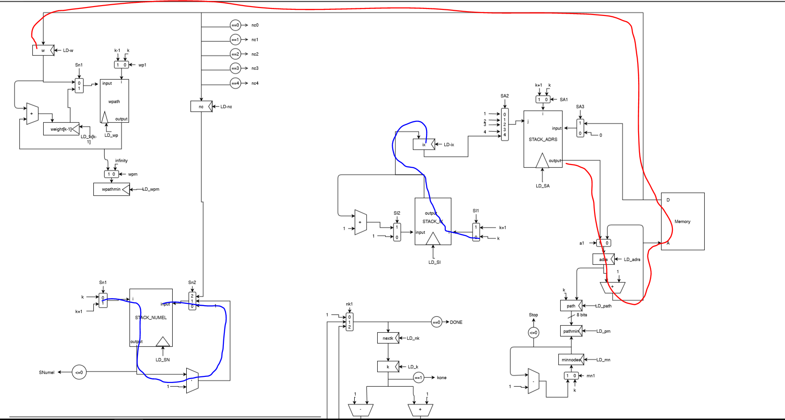

Critical path highlighted in red and blue paths are other stuff happening during this cycle

on the critical path (RED) we have first register then the muxes(all happen in parallel) then register then adder then memory then register.